Instructions
- Answer all questions thoroughly for your proposed shoreline buffer project.
- This is one part of multiple pieces required for a complete stewardship grant application.
- Where the Hennepin County Natural Resources Interactive Map is a suggested resource, you can refer to this guide for assistance.
- A sample shoreline buffer project form is available here.

Questions
- Name of applicant or organization:

- Describe the waterbody or wetland that this buffer will protect. Include the waterbody name, if applicable.

- What is the average width and length of the proposed buffer?
Width is the dimension outward from the water and length is the dimension along the shoreline, demonstrated in the graphic below.
Average buffer width:
Average buffer length:
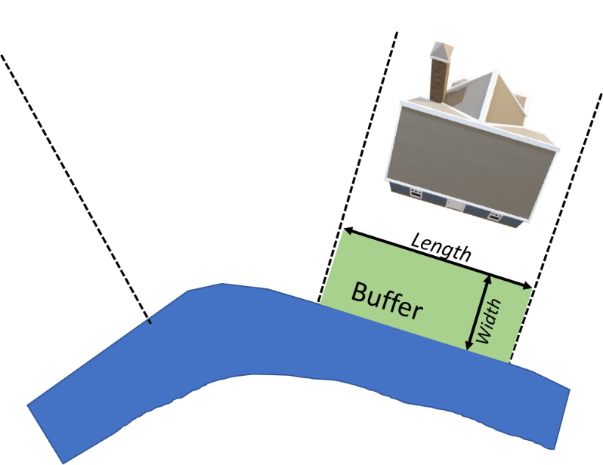
- What is the approximate total size of the buffer in square feet?
The Hennepin County Natural Resources Interactive Map can be used to measure, if needed.

- Provide an aerial photo or map with location of the buffer, waterbody and slope contours shown. The Hennepin County Natural Resources Interactive Map is one source to provide this aerial photo. Follow the directions for “finding elevations and grade changes” on this guide.
Insert the image here or attach the image with your completed application with the title “Question 5”.

- How will you prepare the project area for planting?

- How will you plant your buffer? Seeding Live plants (i.e. plugs or potted plants) Both

- Provide a planting layout.
Plants must be selected from the NMCWD Shoreline Buffer Plant List. Other plants can be used but costs can only be claimed as matching funds. Ensure your planting layout indicates the aquatic and upland sides of the buffer.
Insert the image here or attach the image with your completed application with the title “Question 8”.

Continue to Shoreline Buffer Plant List and other application steps listed at: ninemilecreek.org/get-involved/grants/applications ‎

